

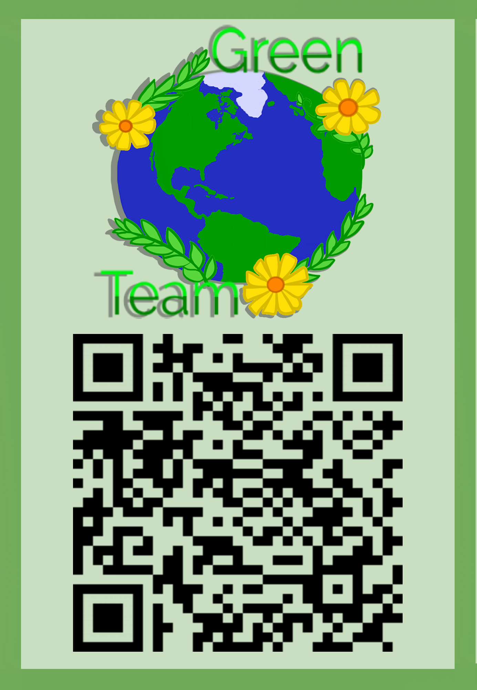

Hackdash:

[**https://hackdash.org/projects/5bc2038d96a2952c33e301b7**](https://hackdash.org/projects/5bc2038d96a2952c33e301b7)

**Mockup:**

[**https://docs.google.com/presentation/d/1OcxrzKshl662KqK38vhNijCiFXNqFeiSu54sNc3wmck/edit?usp=sharing**](https://docs.google.com/presentation/d/1OcxrzKshl662KqK38vhNijCiFXNqFeiSu54sNc3wmck/edit?usp=sharing)

Website: https://ruitingfeng00.wixsite.com/bluehack/blank-page

Video WIP: <https://spark.adobe.com/video/HdHp6WDN9xHNB>

Pexels: **https://www.pexels.com/photo/blank-close-up-crumpled-crumpled-paper-479453/**

**App Name: GreenTeam**

**Ideas:**

* App for average users to connect to.

**Slogan:**

Go Green, Make Green!

**User:**

* Average users
* Businesses - willing to give businesses advertisement
* Town

**Value Proposition:**

* To make it easier for everyone to contribute to a better future for the world through recycling.
* How to get business on board

**Incentives**

* Pickups - based on weight
* Sticker attaches easily to the bins you already have and is scanned and weighed when you have your items picked up.
* Coupons
  + Businesses can advertise in coupons
  + Also increases reputation of businesses because they recycle.
  + Businesses are able to earn money with buy one get one coupons and bring in consumers.
* Tokens (online tokens/points connect straight to bank account) (mainly for businesses)
  + Find partners for different organizations
  + Needs to be localized
  + Sponsors from national chains
* Business incentives
  + Points
  + Tax return

**Marketing:**



**Other**

* **Recycling stats**
  + **The recyclable materials in the U.S. waste stream would generate over $7 billion if they were recycled.**
  + **About one-third of an average dump is made up of packaging material!**
  + **Each year, we use 1 billion plastic shopping bags, creating 300,000 tons of landfill waste.**
  + **Recycling and composting prevented the release of approximately 186 million metric tons of carbon dioxide in 2013, according to the U.S. Environmental Protection Agency, comparable to taking over 39 million cars off the road for a year. (https://www.scientificamerican.com/article/is-recycling-worth-it/)**

**How is this Different?**

**APP Features**

* Information on the types of recyclables (number and type)
* Map with nearby locations of recycling bins and machine
* Point tracks
* RFID Chip in sticker that tracks weights and user points
* Login

**Presentation**

**Problem:**

* Only 42% of Americans recycle regularly <https://www.statista.com/statistics/695426/americans-participating-in-recycling-in-the-united-states/>.
* Pew Research Center: only 28% of Americans live in a place where recycling is strongly encouraged and 22% of Americans live in a place where recycling is not encouraged at all.
* Pittsburgh stuff: <http://www.post-gazette.com/local/city/2015/06/03/Recycling-of-solid-waste-continues-to-grow-in-city-but-still-short-of-goal/stories/201506030145>
  + Pittsburgh has still not set their goal set out in 1988 - to recycle 25% of all solid waste. This goal has not been achieved yet.
* Current Pittsburgh recycling rate is 18% which is below national average of 34%
* <https://www.scientificamerican.com/article/is-recycling-worth-it/>.
  + 1 in 10 Americans admitted to throwing waste in recycling bins.
  + In the District of Columbia, when recycling bins were made 50% larger, “the extensive amount of non-recyclable material put into the bins drove up the city’s processing cost for recyclables and cut profits from selling recyclables by more than 50 percent.”
* https://www.rubiconglobal.com/blog-statistics-trash-recycling/

**Value Proposition:**

* Local City/Municipality
  + Cleaner/more environmentally friendly city.
  + EPA provides economic incentives (grants) to cities based on how much they recycle.
  + Properly recycling material will increase profits from selling recyclables.
* Chain Companies
  + Increase in customers due to points system.
* Everyday People
  + People that already want to recycle: Feel better about themselves, earn points that they can spend at local companies (eateries, clothing etc.)
  + Increased knowledge on how to properly recycle.
    - 1 in 10 Americans have admitted to putting non-recyclable material
    - In DC specifically, it was found that not properly recycling material cut profits from selling recyclables by 50 percent.

Ruiting’s stuff

Change for You. Change for the City.

Change for the city and your pockets. One recyclable at a time.

Go green. Make green.

**MVP (Github Link):**

**Business Model:**

* Getting people to use this device
* Sources of Revenue:
  + Sponsors from companies
    - Companies that accept your points as currency
      * Coupons are specific to a specific region
    - We bring customers to companies (get their names out)
      * Charge them business advertising fees and affiliate fees
  + Ads in app
    - Points toward coupons to use toward that specific company
  + Banner ads
  + Sticker sales
    - People need to buy a QR code to put on their recycling bins to scan for pickup.
    - 33 cents apiece?
* Customer Base:
  + Specifically targeted to the people of Pittsburgh
    - Oakland, Shadyside, Squirrel Hill
    - Housing in Pittsburgh: 132,802 households
    - Current rate of recycling: 18%
* Products:
  + Includes QR code, app
  + Pick Up recycling in conjunction with local pick-up system
  + Hope to implement our own pick-up system in the future
* Financing
  + Grants by the government
    - EPA’s P3 Program
    - Rockefeller Brothers Fund Sustainable Development
  + Donations
    - People

**Business Pitch (Video/Slideshow Link):**

**Technologies Used:**

**Competitive Analysis:**

**How to Beat the Competition**

**How to avoid people from abusing the system (ie, putting garbage in the bin to increase weight):**

* For now we bite the bullet - we don’t know if somebody will or will not abuse this system, but we can see if abuse occurs during initial trial

RFID chip is inside of the sticker given to the user to place onto their bin, which communicates with the on-truck raspberry pi that keeps track of the weight system already implemented to calculate the weight each user has donated.

This system stores the data until the truck returns to its depot, where it will connect with the internet there and upload the data to our system and reward the user their points. This data will be stored in the cloud for six months after this upload, and locally stored on the raspberry pi for a week in case there was an issue with uploading and rewarding.